**Power BI Service Licence**

1. **Free per user licence:**

* Access to content they create for themselves.

1. **Pro licence:**

* Publish content to other work spaces
* share dashboards
* subscribe to dashboards and reports
* share with users who have a Pro license
* storage, up to 10 GB
* 1 GB model memory size limit

1. **Premium per user (PPU) license:**

* Publish content to other work spaces
* share dashboards
* subscribe to dashboards and reports
* share with users who have a PPU license
* larger storage, up to 100 TB of data storage
* 100 GB model memory size limit

1. **Premium Capacity:**

* A capacity-based Premium license (often referred to as a Premium subscription) allows Pro or PPU users to create and save content in Premium capacity work spaces.
* They can then share that workspace with colleagues who have any license type.
* Collaborate with free, Premium per-user, and Pro users by creating and sharing content.
* larger storage, up to 100 TB of data storage.
* 400 GB model memory size limit

# **Power BI pricing**

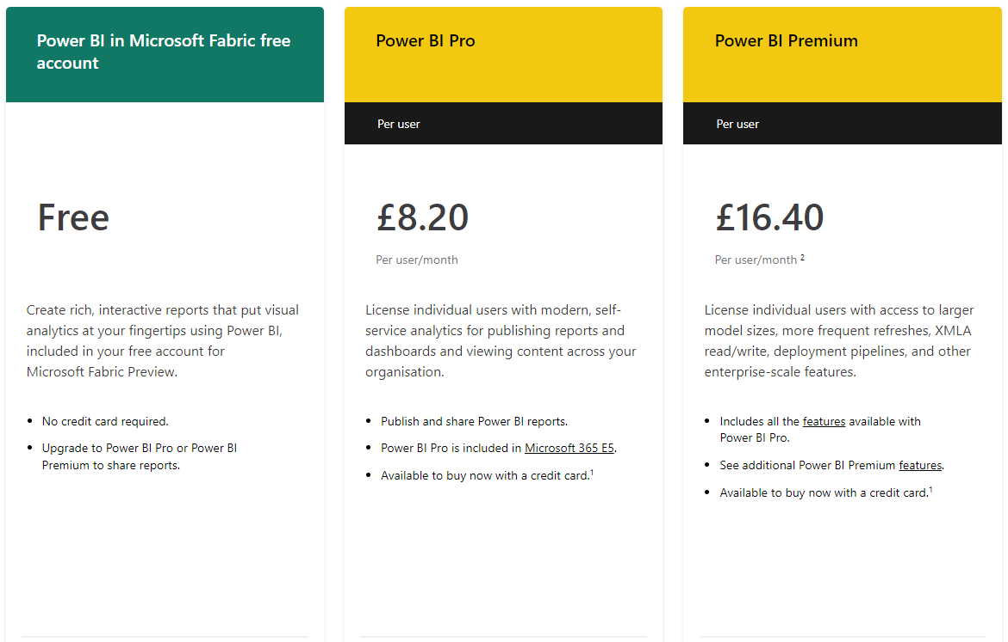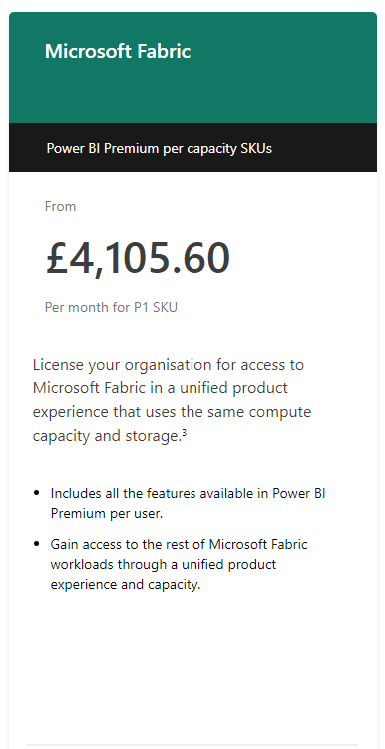

## **Explore Power BI plans**

